# IT 140 Design Document Template

John Melton

IT-140 Introduction to Scripting

Assignment 4

## Storyboard (Description and Map)

You wake up in the cockpit of your spaceship after losing consciousness. You see a red light flashing on your terminal that reads “unidentified lifeform detected”. Your ship is on the way to earth and you must search the ship and eliminate the threat before your ship reaches earth. To kill the alien, you will need to find the**Flamethrower**, the **Fuel**, the **Rations**, the **Spacesuit**, the **Oxygen**, and **Bandages.**

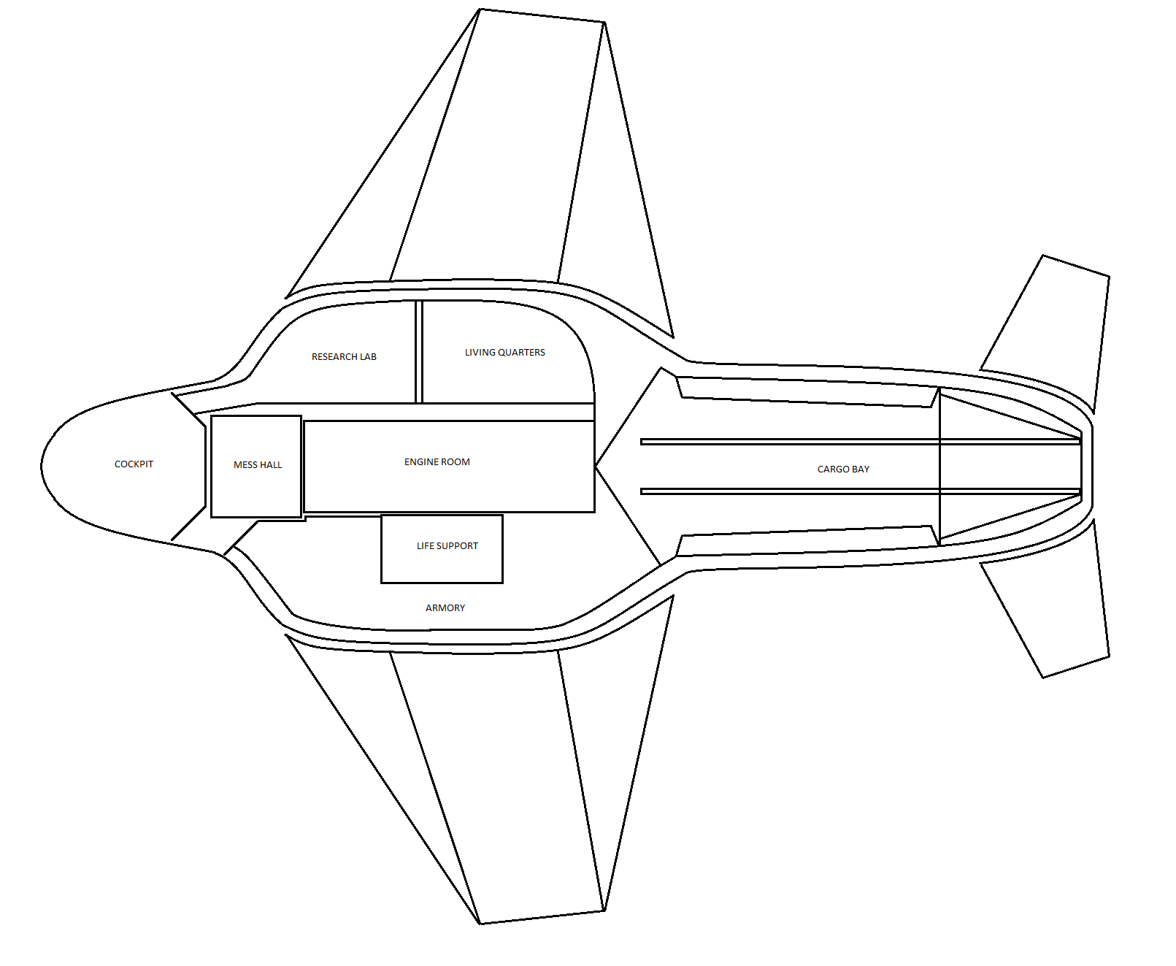

## Pseudocode or Flowchart for Code to “Move Between Rooms”

**WHILE** the player has not given a valid move input

**GET** the room the player is currently in

**GET** the rooms that the player can move to base on the current room the player is in

**DISPLAY** to the user what room they are in and give them options for the rooms they can move to

**INPUT** the direction the player would like to move to

**IF** the player gives a valid input, THEN

**SET** the input as valid

**ENDWHILE**

**SET** the move input as the new current room that the player is in and continue the game.

## Pseudocode or Flowchart for Code to “Get an Item”

**INPUT** when the player is attempting to search the room

**GET** the items that the player currently has.

**GET** the item that is located in the room

**IF** the player already has the item that is in the room

**PRINT** the player does not find anything of use

**ELSE**

**PRINT** the item that the player has found in the room

**UPDATE** the players inventory to include the item that was available in the room